Step 1: Open PowerShell as Administrator
- Press Windows.
- Search for PowerShell.
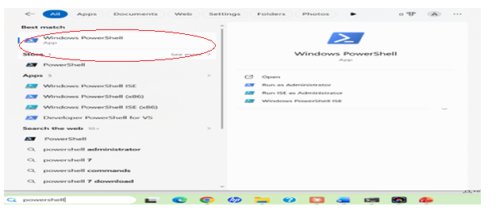
- Right-click Windows PowerShell.
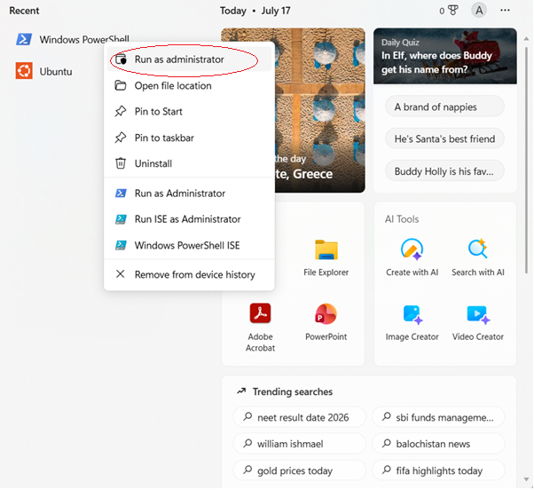
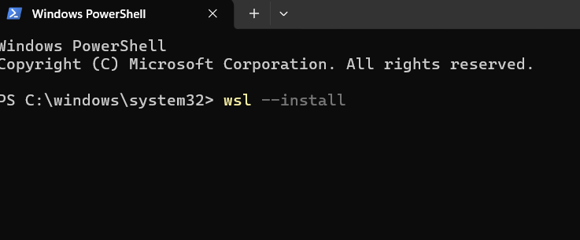
Step 3: Restart Your Computer
After installation, restart your PC when prompted.
Step 4: Complete Ubuntu Setup
After restarting:
- Ubuntu opens automatically (or search for Ubuntu in the Start menu).
- Wait for the installation to finish.
- Create a Linux username.
Example:
Enter new UNIX username: varalakshmi_kanneganti
Step 5: Create a Password
You'll then be prompted to create a password.
New password: ****
Retype new password:****
Step 6: Update Ubuntu
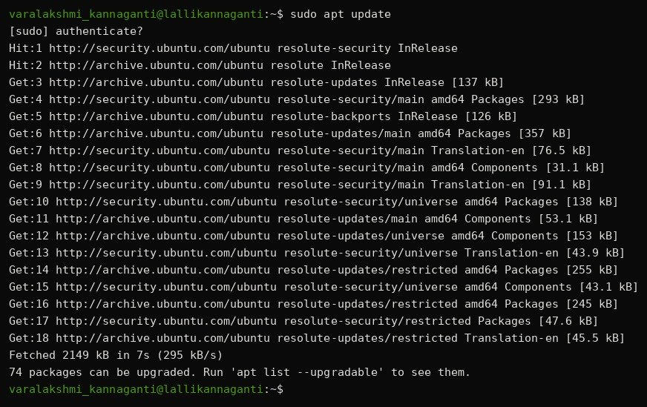

Step 7: Install GCC (C Compiler) 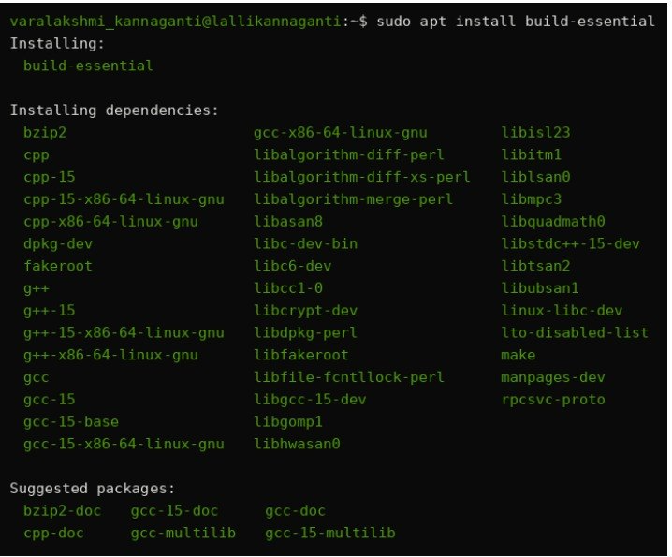

Step 8: Verify the Installation
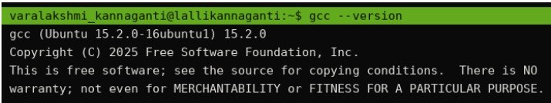
Step 9: Create Your C Program

Example: nano process.c
Step 10: Compile the Program

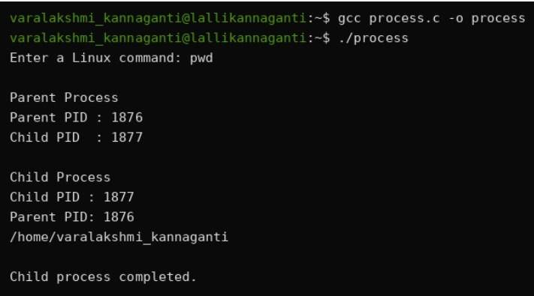

Git Repository:
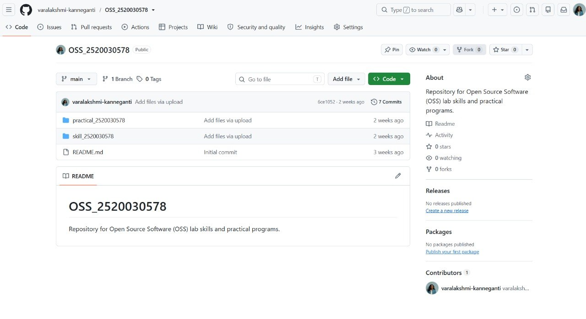
Fork()
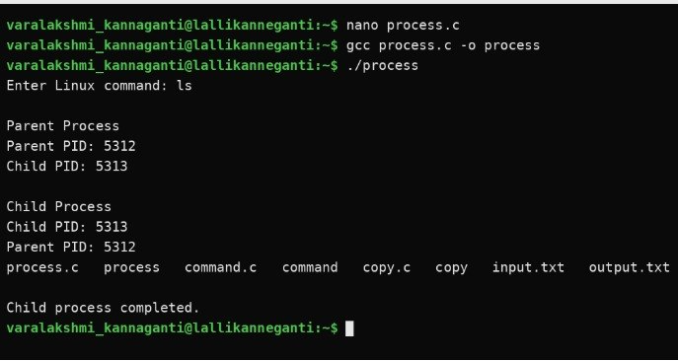

Exce()
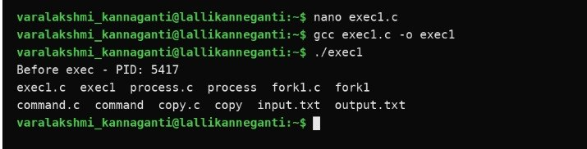
inspect process tree:
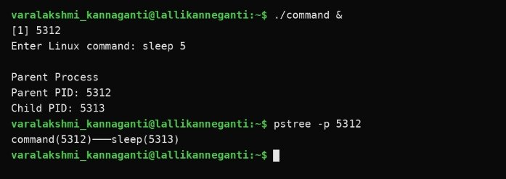

system call tracing:
